34U ENCLOSURE 19" CABINET 600X800 FLOOR STANDING DATA RACK - VALUCAB
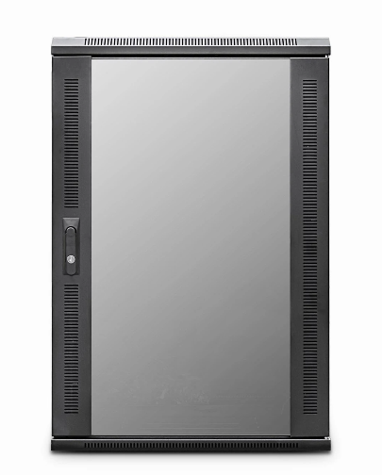

DESCRIPTION

Quality Assembled , Competitively Priced
Need a well priced but quality built data and telecoms cabinet for your
installation or project? With the assurance of the product line being expertly assembled in the UK to the same attention of the rest of the LMS Data EcoNetCab range, the ValuCabs offer all the cabinet functionality you’ve come to expect from LMS Data including adjustable 19-inch uprights, remove side panels, front and rear (reversible) lockable doors and a multitude of cable entry areas.
Ideal for telecom, networking and mixed media applications including CCTV,
broadcast and other data applications, the ValuCab range starts at just 18U, right up
to 42U for larger installations. A choice of standard 600mm and 800mm wide (free
cable management on the 800mm version) and a choice of either industry-standard
600mm deep, or deeper 800mm for larger equipment deployments.

SPECIFICATIONS
34U high 600W 800D
- ETSI 19” front/rear profiles, adjustable
- Lockable vented glass door, reversible
- Removable side panels, rear lockable door
- Ideal for VoIP, CCTV, Networking and CCTV
- Supplied with Castors and Jacking Feet
- UK Assembled and quality assured

TECHNICAL INFO
SKU/MPN: CAB-FE-34U-68NA
EAN: 8400800027153
Weight: 85.0 Kg
Dimensions: 600(width) x800(depth) x1690mm(height)

FILES
Datasheet - CAB-FE-34U-68NA

